

LAB REPORT

**CSE2004 – DATABASE MANAGEMENT SYSTEMS**



**(B.Tech. COMPUTER SCIENCE AND ENGINEERING)**

**FALL SEMESTER 2021-22**

|  |  |
| --- | --- |
| **Name:** | PRASOON SONI |
| **Reg. No:** | 20BCE2960 |
| **Slot:** | L57+L58 |
| **Faculty Name:** | **ANBARASI M MA’AM** |

**VIT – A Place to Learn; A Chance to Grow**

**ASSIGNMENT – 1**

**QUESTION – 1**

**Create the tables described below:**

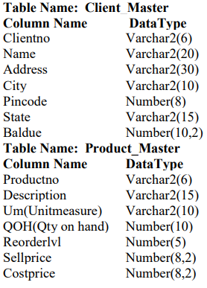

**QUERY**

*-- creating Client_Master table*

CREATE TABLE Client_Master (

    clientno VARCHAR2(6),

    name VARCHAR2(20),

    address VARCHAR2(30),

    city VARCHAR2(10),

    pincode NUMBER(8),

    state VARCHAR2(15),

    baldue NUMBER(10, 2)

);

*-- creating Product_Master table*

CREATE TABLE Product_Master (

    productno VARCHAR(6),

    description VARCHAR(15),

    um VARCHAR2(10),

    QOH NUMBER(10),

    reorderlvl NUMBER(5),

    sellprice NUMBER(8, 2),

    costprice NUMBER(8, 2)

);

**RESULT**

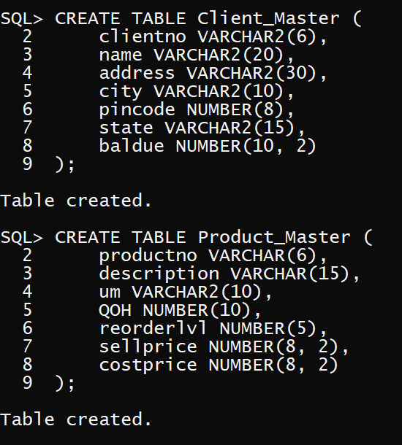

**QUESTION – 2**

**Insert the following data into their respective tables:**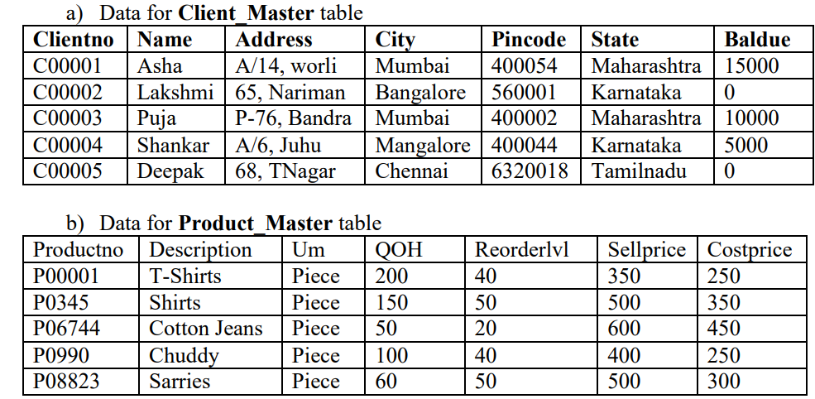

**QUERY**

*-- a. Inserting in Client Master*

INSERT INTO Client_Master VALUES('C00001','Asha','A/14, worli','Mumbai',400054,'Maharashtra',15000);

INSERT INTO Client_Master VALUES('C00002','Lakshmi','65, Nariman','Bangalore',560001,'Karnataka',0);

INSERT INTO Client_Master VALUES('C00003','Puja','P-76, Bandra','Mumbai',400002,'Maharashtra',10000);

INSERT INTO Client_Master VALUES('C00004','Shankar','A/6, Juhu','Mangalore',400044,'Karnataka',5000);

INSERT INTO Client_Master VALUES('C00005','Deepak','68, TNagar','Chennai',6320018,'Tamilnadu',0);

*-- b. Inserting in Product Master*

INSERT INTO Product_Master VALUES('P00001','T-Shirts','Piece',200,40,350,250);

INSERT INTO Product_Master VALUES('P0345','Shirts','Piece',150,50,500,350);

INSERT INTO Product_Master VALUES('P06744','Cotton Jeans','Piece',50,20,600,450);

INSERT INTO Product_Master VALUES('P0990','Chuddy','Piece',100,40,400,250);

INSERT INTO Product_Master VALUES('P08823','Sarries','Piece',60,50,500,300);

**RESULT**

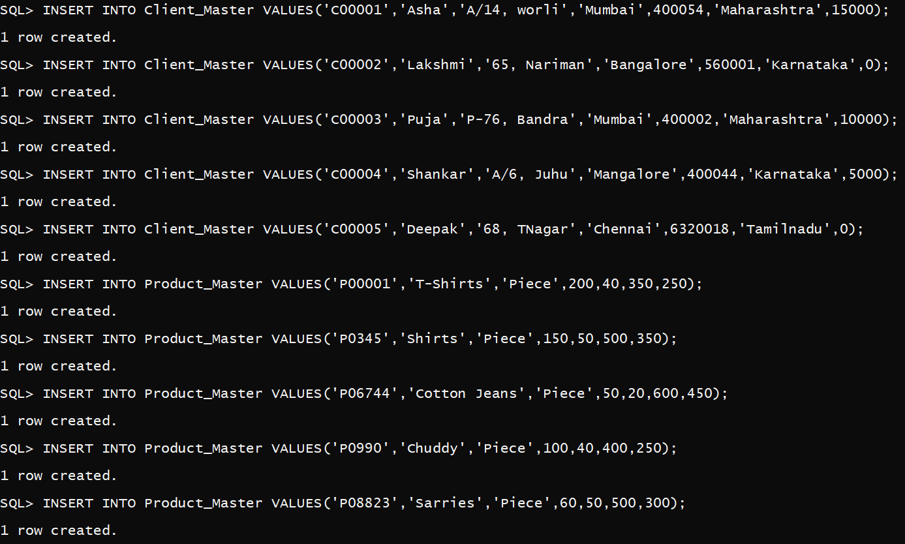

**QUESTION – 3**

**Retrieving records from a table**

a) Find out the names of all the clients

b) Retrieve the entire contents of the Client_Master table

c) Retrieve the list of names, city and the state of all the clients

d) List the various products available from the Product_Master table.

e) List all the clients who are located in Mumbai.

**QUERY**

*-- a. Find out the names of all the clients*

SELECT name FROM Client_Master;

*-- b. Retrieve the entire contents of the Client_Master table*

SELECT * FROM Client_Master;

*-- c. Retrieve the list of names, city and the state of all the clients*

SELECT name, city, state FROM Client_Master;

*-- d. List the various products available from the Product_Master table.*

SELECT description FROM Product_Master;

*-- e. List all the clients who are located in Mumbai.*

SELECT * FROM Client_Master WHERE city = 'Mumbai';

**RESULT**

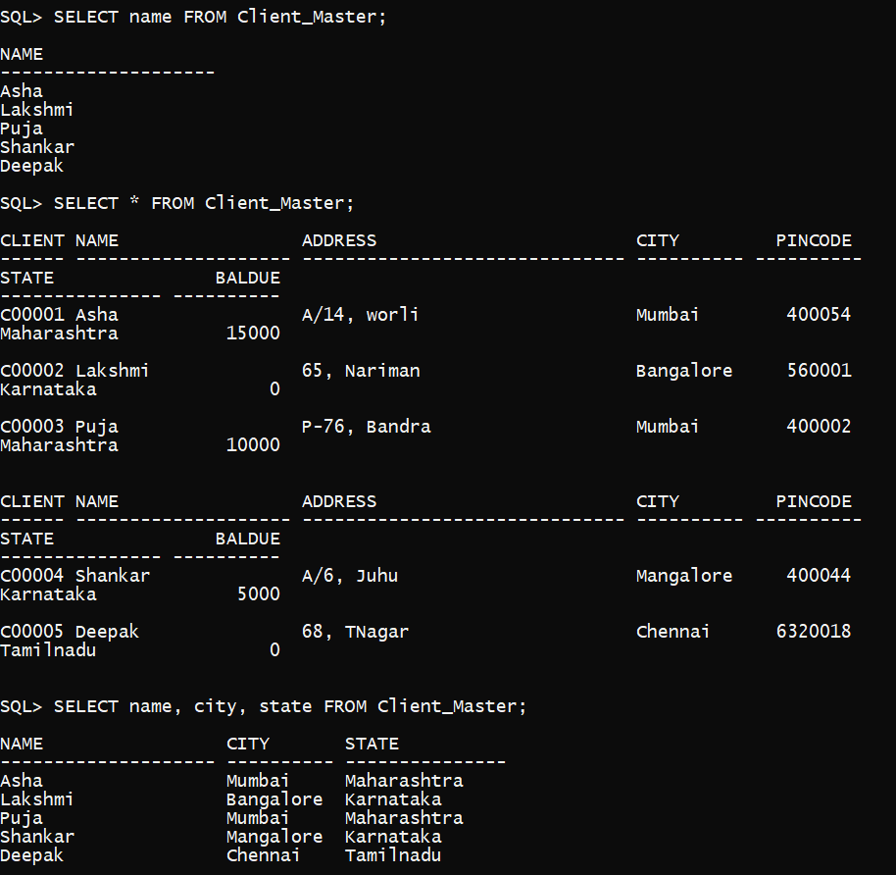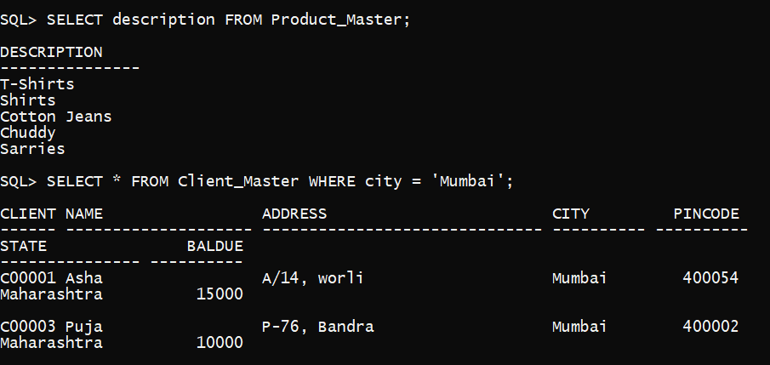

**QUESTION – 4**

**Updating records in a table**

a) Change the City of Clientno ‘C00001’ to ‘Chennai’

b) Change the Baldue of Clientno ‘C00005’ to Rs.1000

c) Change the cost price of ‘shirts’ to Rs. 400

d) Change the QOH of the ‘T-shirts’ to 150

**QUERY**

*-- a. Change the City of Clientno ‘C00001’ to ‘Chennai’*

UPDATE Client_Master SET city = 'Chennai' WHERE clientno = 'C00001';

*-- b. Change the Baldue of Clientno ‘C00005’ to Rs.1000*

UPDATE Client_Master SET baldue = 1000 WHERE clientno = 'C00005';

*-- c. Change the cost price of ‘shirts’ to Rs. 400*

UPDATE Product_Master SET costprice = 400 WHERE description = 'Shirts';

*--d. Change the QOH of the ‘T-shirts’ to 150*

UPDATE Product_Master SET QOH = 150 WHERE description = 'T-Shirts';

**RESULT**

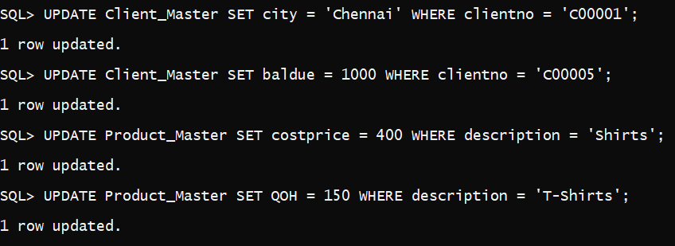

**QUESTION – 5**

**Deleting records in a table**

a) Delete all products from Product_Master where the quantity on hand is equal to 100

b) Delete from Client_Master where the column state holds the value “Tamilnadu”

c) Delete all clients from Client_Master where the Baldue is equal to 0.

**QUERY**

*-- a. Delete all products from Product_Master*

*--where the quantity on hand is equal to 100*

DELETE FROM Product_Master WHERE QOH = 100;

*-- b. Delete from Client_Master where the column*

*-- state holds the value “Tamilnadu”*

DELETE FROM Client_Master WHERE state = 'Tamilnadu';

*-- c. Delete all clients from Client_Master where the*

*--Baldue is equal to 0.*

DELETE FROM Client_Master WHERE baldue = 0;

**RESULT**

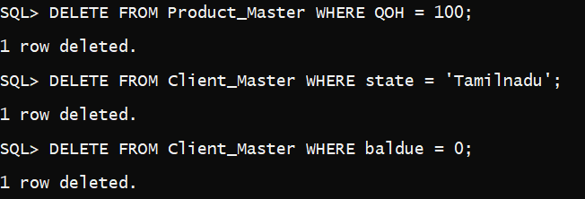

**QUESTION – 6**

**Altering the table structure**

a) Add a column call Profitpercent of datatype number10,2 to the Product_Master

b) Change the size of sellprice column in Product_Master to 10,2

c) Change the name of the column UM to UnitMeasure in Product_Master

d) Drop the column UnitMeasure.

e) Drop the table Client_Master along with its data.

**QUERY**

*-- a. Add a column call Profitpercent of datatype number10,2*

*-- to the Product_Master*

ALTER TABLE Product_Master ADD (profitpercent NUMBER(10, 2));

*-- b. Change the size of sellprice column in Product_Master to 10,2*

ALTER TABLE Product_Master MODIFY (sellprice NUMBER(10, 2));

*-- c.  Change the name of the column UM to UnitMeasure in Product_Master*

ALTER TABLE Product_Master RENAME COLUMN um TO UnitMeasure;

*-- d. Drop the column UnitMeasure.*

ALTER TABLE Product_Master DROP COLUMN UnitMeasure;

*-- e. Drop the table Client_Master along with its data*

DROP TABLE Client_Master;

**RESULT**

